Project Design Phase-II
Technology Stack (Architecture & Stack)

Date | 30 September 2026
Team ID | SWTID-2026-9545
Project Name | Import Data using Transform Maps (Spreadsheet) – ServiceNow
Maximum Marks | 4 Marks

Technical Architecture:
The architecture below shows how the spreadsheet flows through the ServiceNow platform to the reports and dashboard.
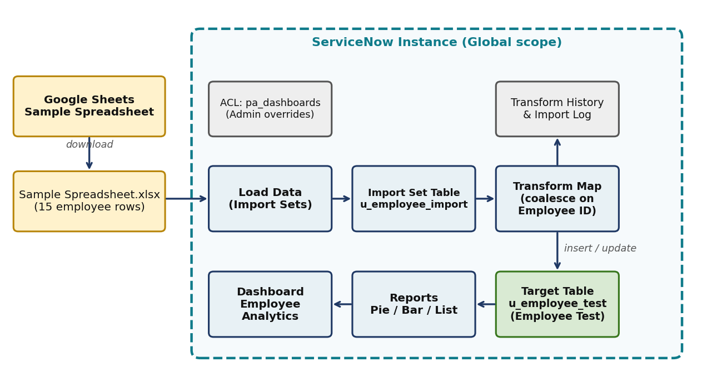
Figure 1: Technical architecture
Table-1 : Components & Technologies:
S.No | Component | Description | Technology
1 | User Interface | Administrator uses the ServiceNow web UI; source data prepared in a spreadsheet | ServiceNow Next Experience UI, Google Sheets
2 | Application Logic-1 | Loads spreadsheet rows into a staging table | Load Data / System Import Sets
3 | Application Logic-2 | Maps source to target fields and inserts or updates records | Transform Map (Field Maps, Coalesce)
4 | Application Logic-3 | Charts and dashboard for insights | Platform Analytics Reports and Dashboards
5 | Database | Staging table u_employee_import and target table u_employee_test | ServiceNow platform database
6 | Cloud Database | Database service is part of the hosted instance | ServiceNow cloud instance
7 | File Storage | Uploaded .xlsx is read by the Import Set loader | ServiceNow instance file handling
8 | External API | Not used in this project | N/A
9 | Machine Learning Model | Not applicable | N/A
10 | Infrastructure | Application runs on the ServiceNow cloud instance (Global scope) | ServiceNow Cloud

Table-2: Application Characteristics:
S.No | Characteristics | Description | Technology
1 | Open-Source Frameworks | None; platform-native low-code configuration | ServiceNow platform
2 | Security Implementations | Role-based access, ACL for pa_dashboards, dashboard sharing by users, groups and roles | ServiceNow ACL, roles
3 | Scalable Architecture | Staging (Import Set) separated from the target table; transform maps reusable | ServiceNow Import Sets
4 | Availability | Managed cloud hosting of the instance | ServiceNow Cloud
5 | Performance | 15 rows processed in about 1.4 seconds; indexed coalesce key on Employee ID | Transform Map coalesce

